CIS/STA 39200, 8-1-20 Prof. L. Tatum
Lecture Notes 7: Classification Using Logistic Regression
Section Topic
1 Social Welfare and Voting by State in 2008
2 Logistic Regression
3 Exercises
In this lecture note, you will have a quick introduction to logistic regression and then learn how to use R to perform logistic regression. In the following lecture note, you will learn how to use a sophisticated model selection program for logistic regression.

Section 1: Social Welfare and Voting by State in 2008
How well do social welfare statistics for a State predict voting for the President? Will the number of Medicare recipients per 100,000 usefully predict if a State will vote for a Democrat or a Republican in a Presidential election? Or, the number of Hospital Beds per 100,000? In this section, we will start to examine the relationship by State between several measures of social welfare and Presidential voting in the 2008 election. In the matrix scatterplot, below, blue dots represent states that voted for Obama, red that voted for McCain.
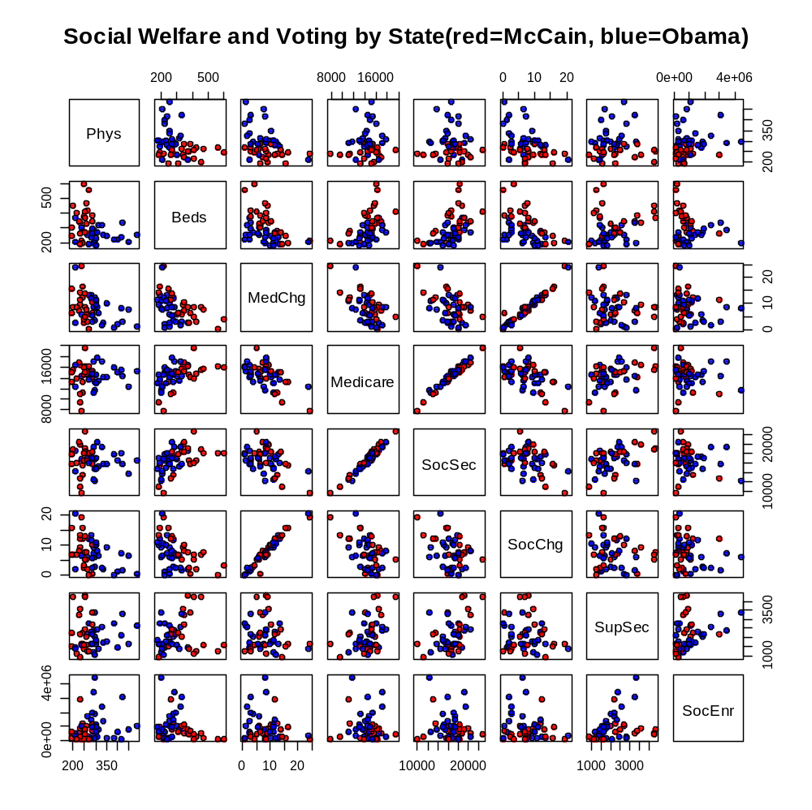
In the matrix scatterplot, the following 7 numeric variables were used (by State):

Phys Number of physicians in the state per 100,000 residents
Beds Number of beds per 100,000 residents
MedChg Change in number Medicare recipients per 100,000
Medicare Number of Medicare recipients per 100,000
SocSec Number of Social Security recipients per 100,000
SocChg Change in number of Social Security recipients per 100,000
SupSec Number of recipients of Supplementary SS per 100,000
SocEnr Total number of enrollees in SS system

To get acquainted with this display and the data set, we need to drill down and see what is going on, in detail. Consider the rather strange appearance of four plots in which the points fall along diagonal lines with positive slope. How many variables share a high level of positive correlation, then? The answer is two sets of two variables each. It seems like more, but remember that a plot of (Phys, Beds) also shows up as (Beds, Phys), so each pair is plotted twice. Thus, two highly correlated pairs yield 4 plots with a linear relationship.
One of those pairs occurs in the third row, sixth column, MedChg vs. SocChg. Let’s take the blue point in the upper right-hand corner. Looking up, we find the x-axis scaling shown for SocChg, and we see that point has a value of SocChg of approximately 20. That means there was an increase of about 20 recipients of Social Security per 100,000 in that State in the last year. For the y-axis, we see that there was also approximately an increase of 20 recipients of Medicare per 100,000 residents.
What State was that? Going to the “Hospital” CSV data set, we can either open in Excel or read into R. Then we can look for that State! Looking down the columns, I believe it is NV, for Nevada, with MedChg = 23.7 and SocChg=20.69. What happened in Nevada to produce this data point? One guess is that a relatively large number of older people retired to Nevada that year and began receiving both Social Security and Medicare. Another possibility is that a lot of young people left in that year! It could also be a “baby boom” bump of people turning 65. Also, Nevada has a relatively small population so it takes fewer people to produce a shift of 20 per 100,000 than it would in New York State.

Section 2: Logistic Regression

In ordinary regression analysis, we have two variables: a random variable Y and an observed variable x. The regression model (and our software) assumes that the Y random variable has a Normal probability distribution conditional on knowing the value of a second variable, x. The expected value Y conditional on x is modeled as a linear function of x. The regression model (and the software) assumes that the true standard deviation of Y|x is constant and therefore does not change with x.
In logistic regression, the probability distribution of Y is no longer a Normal distribution; Y is now restricted to only two possible values. We say Y is a dichotomous variable – a variable that takes a value of either 1 or 0, yes or no, or Obama or McCain. Thus, there can be no bell-curve distribution for Y.
The logistic regression model takes information from the observed value of x and produces an estimate of the probability that Y will take the value 1. Thus, the model does not directly predict whether Y will take 1 or 0 given the x-value. For example, let π_{i} denote the probability that the i^{th} State votes for Obama. We want, then, to localize our probability π_{i} given, say, the number of hospital beds per 100,000 residents.
The difficulty is that π, as a probability, is limited to a range of 0 to 1. Thus, we cannot use ordinary regression methods. What we do is to use a function which has a portion of what looks like a linear regression structure, = b_{o} + b₁ x, but it puts the
b_{o} + b₁ x
portion as an exponent to e, the exponential number, which is approximately 2.71828. After some subtle razzle-dazzle, we end up with the following equation for a “logistic curve” foras a function of x:

= 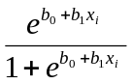.

Is this function bounded between 0 and 1? Let’s set b₀=0 and b₁ = 1; what happens when x_{i} is positive and made larger and larger? Then both the numerator and denominator will become very large at the same rate, and their ratio,, will approach 1. When x_{i} is negative and made larger in the negative direction, then will approach 0 because the numerator approaches zero and the denominator approaches 1. Finally, when x_{i} = 0, we get a lovely result: what is it? So, we are surprised and pleased to see that this strange equation produces values strictly between 0 and 1!
The arbitrary nature of that choice of a curve bothered me a great deal as a student, but eventually I came to accept it: it is a way to move forward in a difficult situation. Do not let the arbitrary nature of this function slow you down: take it seriously because it is a key piece of machinery by which regression methods are connected to the problem of classification
As an illustration as what that function can do, the pink curve below was produced by setting b_{o}=9 and b₁=-0.03, by trial and error, to get a reasonable fit to the data.
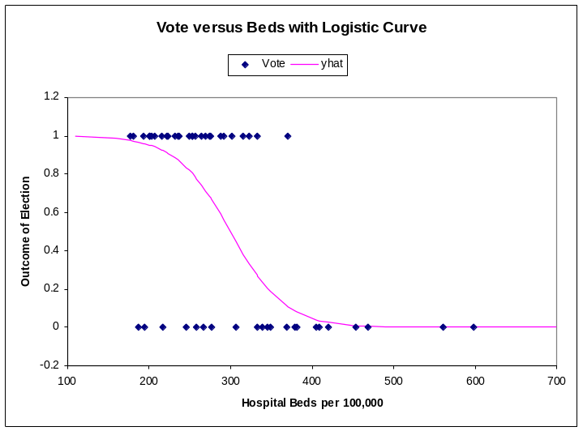

Turning to software and iterated maximum likelihood estimation, we can optimally fit the above model. Also, we can also expand it to allow for multiple x-variables, to get multivariate logistic regression.
Now, how do we convert our estimated probability to a forecast? Once again, we merely say that if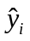is greater than 0.5000, then we predict that i^{th} State will vote for Obama.
At this point, I will work in parallel with the presentation on logistic regression in Section 4.6.2 starting on page 156 of ISL. We will use a “generalized linear models” program called glm, which is built-in to R. For simplicity, we will not be data-splitting into train and test data. There is nothing obvious about how to use glm to call the logistic regression function: we just have to accept the syntax as given!
The glm program wants us to input the full data set as one data frame and to then call the columns using their column names. For example, the y-variable will be referenced by the name Vote and one of the x-variables will be named Beds. Of course, we will need to tell the function the name of the data frame: Hospital. And, we need to tell glm which of many possible methodologies we want to use. To specify logistic regression, we use the option “binomial.”
When R performs a regression analysis, we save the output and then only call up the pieces we want. Following the ISL text, I will save my output as “glm.fit.” Then, to see the usual regression output, use the summary function: “summary(glm.fit).”

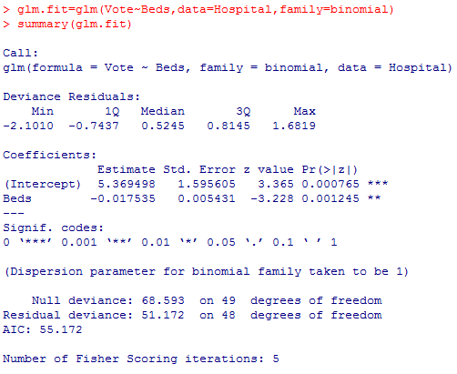

Earlier, by trial and error, I got rough values of b_{o}=9 and b₁= -0.03. By a more extensive and sophisticated trial-and-error methodology, our program has produced estimates of b_{o}=5.369 and b₁= -0.0175.

I will now show how to use two x-variables: Medicare and Beds. Note the use of the addition symbol between the two x-variables. The “summary” output is shown so you can see the slope coefficients for Medicare and Beds, as well as p-values for the corresponding hypothesis tests that the true slope is zero. Since the p-values are less than 0.05, both variables should be retained in the model.

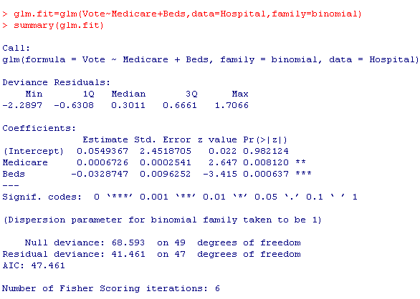

How do we translate this fitted model into forecasts about voting? First, we ask the “predict” function to output the y-hat values, which will be estimates of π_{i} for each of the 50 states. The first argument to the predict function will be glm.fit and the second argument will be type=“response”. That call to the predict function is shown below, with the output of the function named glm.probs. The glm.probs output consists of estimates of the probability that each of the 50 States would vote for Obama. The first four estimates are shown below.
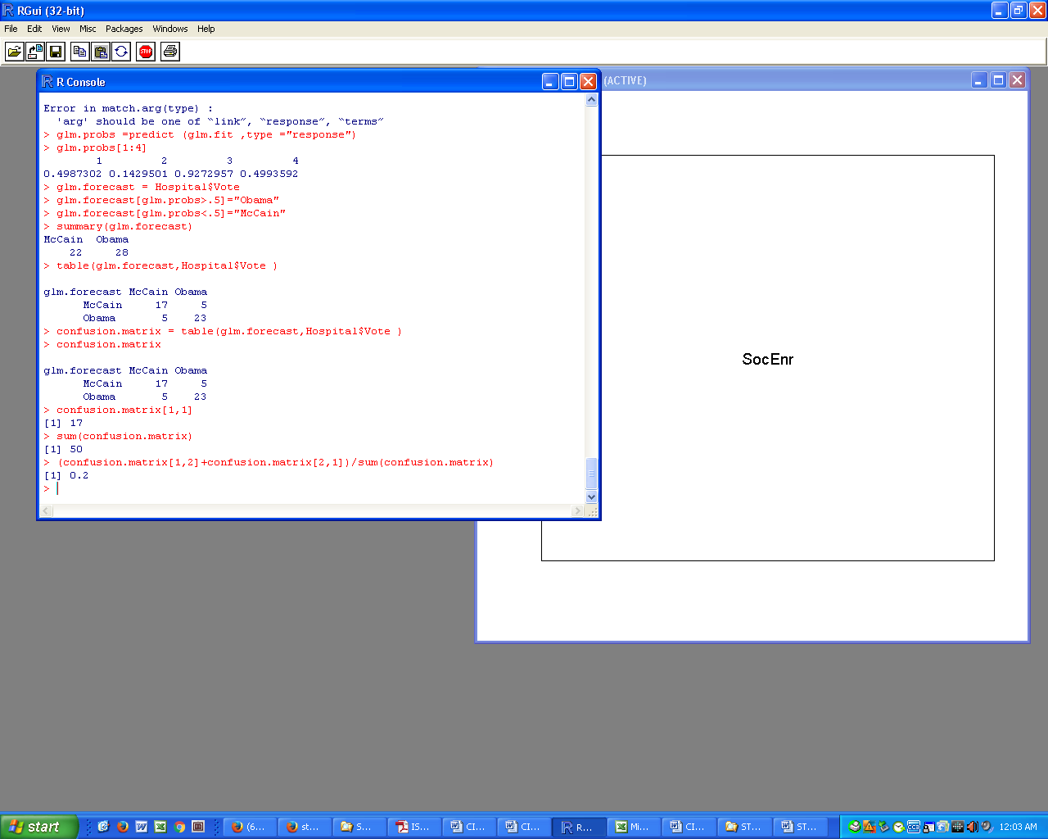

The value 0.4987302 is the estimated probability that AL (Alabama) will vote Obama, while 0.9272957 is the estimated probability that AZ (Arizona) will vote Obama…a surprisingly high figure given that Obama did not win AZ! Oh well, that’s forecasting from hospital beds!
Next, we need to translate those estimated probabilities into vote forecasts. Our vote forecast will be either “Obama” or “McCain” for each state.
This will look a little different from the ISL step because I am going to work directly with the Vote column as is, rather than translating to 0 and 1 values.
The easy way to get the vote forecasts is to use the round function directly on the estimated probabilities. Then, input the vote forecasts and the Vote itself into the table function.
Alternatively, here is a long and careful method. First, I am going to create a glm.forecast column in which to put the forecasts. To make sure it is of the same data type as Vote, I will start with a copy of Vote.

Next, wherever the forecast was greater than 0.5, I insert the name “Obama” into the vote forecast column. This style of statement in R takes getting used to, but it is quite powerful. Then, I insert “McCain” wherever the forecast was less than 0.5. The summary function than gives a convenient count of the Obama and McCain forecasts.

Now, we can avail ourselves of the “table” function, which will perhaps seem familiar! This will give us what ISL calls the “confusion matrix,” which will show where and how many errors were made in the vote forecast by outcome.

Thus, the vote forecast error rate was (5+5)/50 = 0.20 = 20%.
We can automate that computation in case we need that at a later time. First, we make sure we understand how to pull out individual elements of the 2x2 confusion matrix. I learned how to do this by experimentation on the output of the table function. Once I knew how to call the values from the table function output, then it was obvious how to automate the computation of the error rate.

Lecture Notes 7: Exercises

7.1. Use the Hospital data.

(a) Use the sample function to select 4 out of the 8 x-variables to use in logistic regression. For example, I ran the sample function with the following results:
>sample(1:8,4)
[1] 6 3 8 7
meaning that I would take the sixth, third, eighth, and seventh x-variables. Run that function yourself, show the output, and state which x-variables you will use.

(b) For the x-variables you selected above, use logistic regression to estimate the probability each state votes for Obama.

(c) Convert the estimated probabilities into vote forecasts. Then show the confusion matrix and find the vote forecast error rate.

7.2 Try out logistic regression on the classification of your daily standardized log range data (high/low) you have been using. Use at least lag1 and lag2 as x-variables.

(a) How well did logistic regression perform on your data relative to Naive Bayes and k-Nearest Neighbors? Compare the forecast error rates from the table function.

(b) Using lag1 and lag2 as regressors, prepare a classification plot for your log range data using logistic regression.

